BEYOND BONDED BOARDS
EPTEK PRECISION CAST TOOLING
From Bonded Boards to Monolithic Close-Contour Casting
Automotive Models • Aerospace Tooling • Precision Fixtures
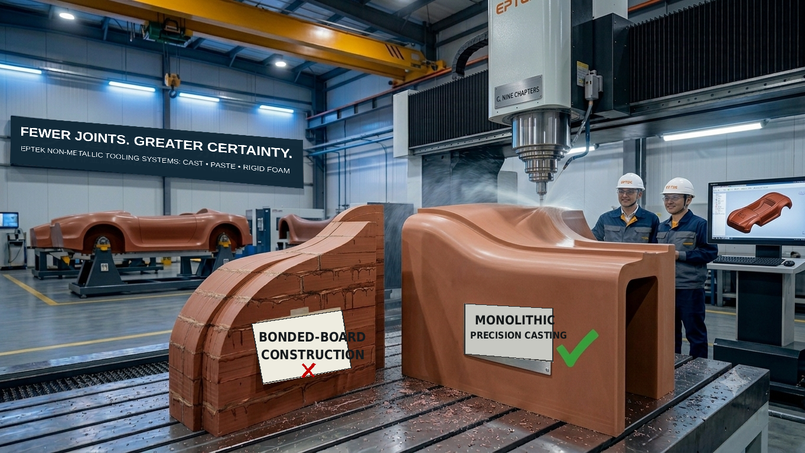
Five-axis CNC machining of a monolithic cast tooling blank, with no bonded-board seams and a smooth, continuous surface.
In automotive styling, model validation and precision aerospace tooling, blank quality determines whether complex surfaces can be reproduced continuously and design dimensions transferred reliably. It also directly affects the efficiency of downstream bonding, repair and machining.
For large components, deep cavities and complex geometries, conventional tooling boards must be cut into multiple sections, bonded and cured before the assembly can be machined as a whole. Seams, adhesive layers and repeated finishing extend the process and introduce uncertainty in surface consistency, vacuum integrity and long-term dimensional stability.
To move beyond bonded-board construction, EPTEK developed Precision Cast Tooling. Starting with customer-supplied 3D data, EPTEK designs a dedicated close-contour casting cavity and produces a monolithic near-net-shape blank—moving complex models and tools from panel assembly to integrated casting.
“Fewer joints. Greater manufacturing certainty.” This is the principle behind EPTEK Precision Cast Tooling.

01 | FOUR LIMITATIONS OF BONDED TOOLING BOARDS
Conventional tooling boards are typically supplied as standard rectangular panels. Producing large components, deep cavities or complex freeform tools requires panel nesting, cutting, rough machining, adhesive application, assembly, clamping, curing and seam finishing. Standard boards remain convenient for small, regular parts; however, their inherent limitations become more pronounced as component size, surface complexity and vacuum requirements increase.
● Visible seams are difficult to eliminate
Adhesive layers and tooling boards differ in colour, hardness, coefficient of thermal expansion and sanding behaviour. Even after filling, sanding and painting, seams may reappear on high-gloss finishes, Class-A surfaces or after prolonged temperature variation, compromising the surface consistency of styling models, master models and premium tooling.
● Vacuum integrity can be compromised
Seam zones, adhesive edges and locally incomplete bonds can create hidden channels or micro-voids. In vacuum-forming tools, composite lay-up masters and vacuum trimming fixtures, these defects may become leakage paths, reducing vacuum level or causing unstable vacuum retention.
● Bond lines can limit service life
Bond lines are discontinuities within the overall structure. Repeated handling, machining, vacuum loading, mechanical loads and thermal cycling can lead to local debonding, cracking or steps at the seams, increasing the risk of repair and recalibration.
● Manufacturing efficiency is lower
Traditional board assembly requires panel cutting, adhesive application, positioning, clamping, curing, seam repair and secondary datum setting, followed by removal of substantial material from a rectangular blank. Monolithic close-contour casting places the required machining allowance around the final geometry, reducing excess material and rough-machining work.
BONDED-BOARD CONSTRUCTION | Nest & cut → rough-machine → bond & clamp → cure → repair seams → re-datum → heavy roughing
CLOSE-CONTOUR CASTING | 3D data → dedicated cavity → monolithic casting → focused finish machining
Standard boards still make sense for small, regular components. Their disadvantages become most pronounced on large tooling, deep cavities, complex surfaces, vacuum applications and projects with demanding cosmetic requirements.

02 | CLOSE-CONTOUR CASTING: A NEW BLANK-MANUFACTURING ROUTE
EPTEK Precision Cast Tooling follows the internationally recognised Close-Contour Casting route: a three-dimensional, near-net-shape blank is cast around the final product geometry. Compared with stacked and bonded boards, the process reduces material removal, CNC machining time, tool wear and chip waste while providing a continuous surface without board seams.
This is more than a change in material form; it reconfigures the entire blank-manufacturing workflow. From 3D data and cavity design through monolithic casting and precision machining, material is placed around the final product contour. The blank retains only the required machining allowance and can proceed directly to CNC or five-axis finishing, eliminating panel cutting, bonding, curing and seam repair.
PROCESS STEP | DESCRIPTION
01 Data & tool design | Design a dedicated casting tool from customer-supplied 3D data, defining machining allowance, insert positions, vacuum circuits and other process details.
02 Cavity machining | CNC-machine the foam casting cavity to reproduce the product geometry accurately while controlling material consumption and approaching the final contour.
03 Casting & cure | Cast liquid polyurethane (PUCAST®) or epoxy (EPCAST®) and cure it into a monolithic structure. Thick-section parts may use staged cure and post-cure schedules.
04 Minimal finish machining | Demould a monolithic blank with limited machining allowance. Light finish machining produces the final part; on suitable projects, machining time can be reduced by more than 50%.

EPTEK selects the PUCAST® polyurethane or EPCAST® epoxy system according to component size, service temperature, surface hardness, compressive performance, weight and machining requirements. Thick-section, high-precision or elevated-temperature parts may use staged curing and post-curing to reduce internal stress and stabilise final properties.
03 | PRECISION CAST TOOLING VS. BONDED BOARDS
The value of precision cast tooling is not simply to replace a standard board. It brings the starting blank much closer to the final geometry.
CRITERION | BONDED TOOLING BOARDS | EPTEK PRECISION CAST TOOLING
Dimensional stability | Multiple adhesive interfaces may deform differently as temperature changes. | A continuous monolithic structure, controlled formulation and post-cure support uniform dimensional behaviour.
Vacuum integrity | Bond lines and voids can create leakage paths, making vacuum performance difficult to maintain. | Fewer panel interfaces reduce potential leakage paths.
Machining efficiency | Panel cutting, bonding, curing, seam repair and heavy rough machining create a long process chain. | Near-net-shape allowance shortens roughing paths and reduces tool wear.
Service life | Bond lines are relatively weak zones and may debond or crack under thermal and mechanical loading. | Eliminating panel bond lines allows service life to be optimised through material system, density and structural design.
Total cost | Economical for small, regular parts, but assembly and rough-machining costs rise sharply on large tools. | A dedicated cavity requires an initial investment, but total lead time and cost are more controllable for large, complex tools.
Project-specific weight reduction, machining efficiency and lead time depend on component size, material density, structural design, machining allowance and acceptance criteria. Standard boards may remain more economical for small, regular and extremely urgent parts; monolithic close-contour casting is generally more efficient for large components, complex surfaces, vacuum sealing and high-quality finishes.

04 | AUTOMOTIVE STYLING, MODELS AND TOOLING
Automotive applications account for approximately 50% of EPTEK Precision Cast Tooling projects. The technology supports the workflow from early styling validation and engineering-data confirmation through interior and exterior models, functional models, checking fixtures and low-volume moulds.
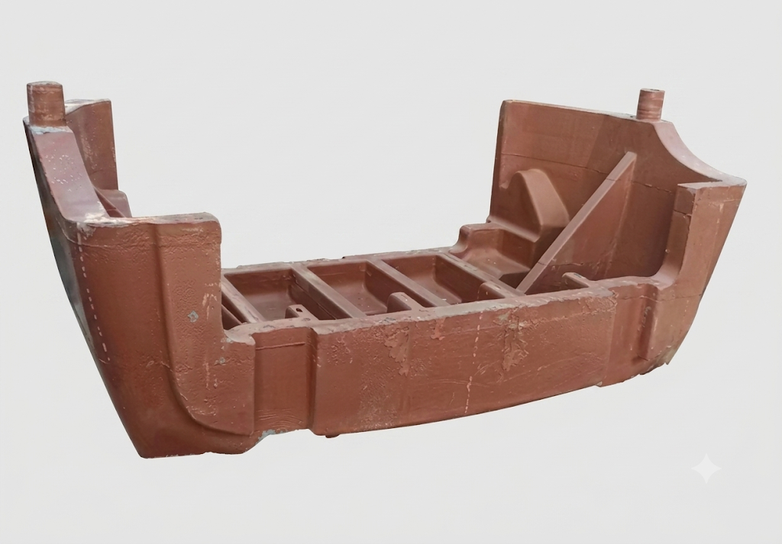
Automotive styling model: a monolithic cast blank supports seamless Class-A surface reproduction.
● Styling models and master models
Suitable for full-vehicle exteriors and styling models of body sections, bumpers, fenders, front and rear fascias, spoilers, wheel arches, lamps, grilles and aerodynamic components. For large surfaces, deep cavities or irregular structures, the monolithic blank reduces the risk of board seams becoming visible beneath high-gloss paint and supports clay-to-CAD transfer, Class-A surface review and final design release.
● Data-control and cubing models
Vehicle or subassembly data can be used to manufacture data-control models, matching models and assembly-validation models for checking gaps, flushness, boundary relationships and assembly compatibility. High dimensional stability, good edge retention and a fine surface finish are critical material requirements.
● Interior and exterior models and tooling
Applications include instrument panels, door panels, centre consoles, pillars, headliners, seat components, luggage-compartment trim, lamps and new-energy-vehicle body panels. The material can also be used for vacuum-forming moulds, low-pressure RIM moulds, foam moulds, soft-trim tooling and low-volume composite moulds.
● Checking fixtures, assembly fixtures and component supports
Suitable for contour checking fixtures, locating fixtures, assembly supports, measurement bases and display tooling for body panels, interior and exterior trim and structural components. The blank can be cast close to the required support contour and then machined with datum holes, locating pins, checking blocks and metal inserts—balancing accuracy, weight and ease of handling.

05 | AEROSPACE TOOLING APPLICATIONS
Aerospace composite and sheet-metal parts are often large, thin-walled, low in stiffness and characterised by complex curvature and demanding accuracy requirements. Dedicated tooling is required throughout lay-up and forming, trimming and drilling, inspection and assembly. Aerospace applications currently represent approximately 50% of EPTEK Precision Cast Tooling projects.
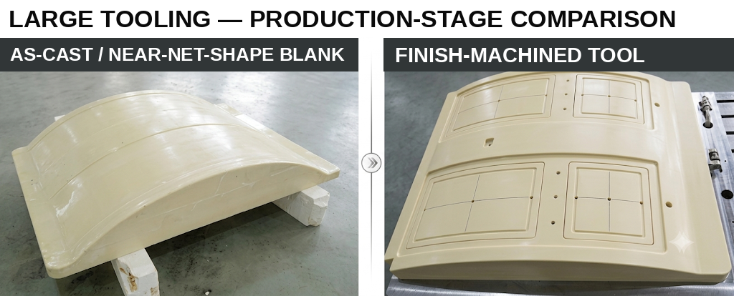
Large tooling blank before and after machining: the near-net-shape cast blank minimises stock removal while retaining the required surface allowance.
● Composite-tooling master patterns
A master pattern is the high-precision reference used to manufacture a production composite mould. EPTEK can cast a monolithic blank directly from composite-part or final-tool data. Five-axis machining produces a continuous surface, followed by sealing, coating, gelcoat or release treatment. Typical applications include master patterns for carbon-fibre wing skins, fuselage panels, doors, fairings, wingtips, spars and ribs.
• For low- or medium-temperature composite master patterns, select a polyurethane or epoxy system according to lay-up material, cure temperature, number of thermal cycles and accuracy requirements.
• For prepreg-tool master patterns, verify heat-deflection temperature, coefficient of thermal expansion, post-cure schedule and compatibility with the gelcoat system.
● Vacuum holding and trimming fixtures
After cure, composite parts are commonly located on vacuum holding and trimming fixtures that match the part surface. EPTEK Precision Cast Tooling forms the fixture body as a single blank, after which CNC machining creates the matching surface, vacuum grooves, air channels, seal grooves and locating datums. Unlike bonded-board vacuum fixtures, the monolithic blank has no board seams crossing the working surface, reducing the risk of bond lines becoming leakage paths.
• Typical parts: carbon-fibre wing skins, fuselage panels, doors, fairings, honeycomb sandwich panels and composite interior components.
• After machining, perform surface sealing, seal-continuity inspection, zoned vacuum testing and a full-fixture vacuum hold test.

05 | AEROSPACE TOOLING APPLICATIONS — CONTINUED
● Stretch-forming and sheet-metal-forming tool blanks
Aircraft aluminium skins and thin-sheet components require moulds with accurate surfaces, sufficient compressive strength and good wear resistance during low-temperature stretching, stretch forming, hand working and corrective forming. For development programmes, low-volume production and complex surfaces, resin tooling can be five-axis machined rapidly and is easier to handle and modify than metal blanks.
● Inspection tooling and assembly fixtures
Inspection and assembly of aerospace components require reliable datum transfer, contour location and repeatable clamping. EPTEK Precision Cast Tooling can be used for contour gauges, surface gauges, assembly-locating fixtures, drill-template bases and bonding fixtures. A monolithic cast blank creates complex support contours at relatively low weight and can incorporate locating pins, bushes, threaded inserts, ball seats and measurement targets.
For aerospace projects, material selection and cure schedules must be validated against service temperature, thermal-cycle count, dimensional accuracy, coating or gelcoat compatibility, vacuum requirements and the final inspection plan.
06 | EPTEK PRODUCT PORTFOLIO
EPTEK offers a complete material and equipment portfolio for automotive styling, aerospace moulds and precision tooling—from styling clay, lightweight cores and tooling boards to precision cast tooling, paste tooling, water-soluble core materials and five-axis machining systems.
PRODUCT FAMILY | KEY FEATURES AND APPLICATIONS
PUCAST® Polyurethane Precision Cast Tooling | Fast curing, excellent machinability, low dust generation and flexible density options. Suitable for automotive styling models, checking and assembly fixtures, vacuum trimming fixtures and low-temperature composite master patterns.
EPCAST® Epoxy Precision Cast Tooling | Excellent dimensional stability, good elevated-temperature performance and low thermal expansion. Suitable for higher-temperature composite master patterns, prepreg-tool master patterns and precision inspection fixtures.
PUBOARD® / EPBOARD® Tooling Boards | Polyurethane and high-temperature epoxy tooling boards for small models, rapid tooling, checking fixtures and prepreg-tool master patterns.
PUFOAM® / LBOARD® Lightweight Core Materials | Fine-cell rigid polyurethane foam for large master patterns, lightweight master models, composite-tooling master patterns and internal support for conformal structures.
EPMOLD® Paste Tooling Material | For surface layers on large master patterns, fairing of complex surfaces, local modifications and hand- or machine-applied tooling production.
EPMOLD® Tooling Resins & Prepregs | High-performance systems for aerospace composite tooling, including vacuum-infusion moulds, prepreg moulds and high-temperature composite tooling.
iClay Styling Clay | For automotive styling development and design validation. Reworkable and easy to finish for Class-A surface model production.
Water-Soluble Core Materials | For forming complex hollow composite structures. After cure, the core can be removed with water, overcoming the demoulding limitations of conventional core tools.
PROJECT ENQUIRIES
Custom seamless cast tooling blanks, models, moulds and fixtures
Send us your 3D data. EPTEK can deliver the complete solution—from a precision-cast blank to a finished five-axis-machined part.

